U.S. AbilityOne Commission

Report to the President
For the period October 1, 2019 − March 15, 2021

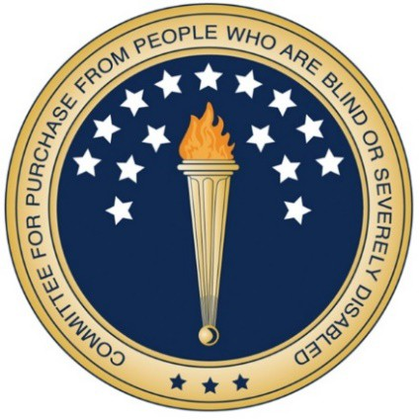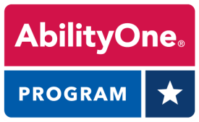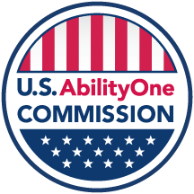

March 2021

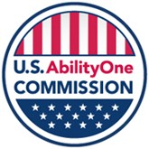

President Joseph R. Biden, Jr. March 23, 2021
The White House
1600 Pennsylvania Ave, NW
Washington, DC 20500

Dear Mr. President,
On behalf of the U.S. AbilityOne Commission, I am pleased to submit this report about the value and impact of the Commission and the AbilityOne Program it oversees for the period of Oct. 1, 2019, through March 15, 2021. AbilityOne provides employment opportunities that enable people who are blind or have significant disabilities to achieve their maximum employment potential.
AbilityOne’s value to America is at a historic high with the Program’s extraordinary performance in responding to the COVID-19 pandemic crisis. As we mark the one-year anniversary of this national emergency, we also recognize that more than 42,000 AbilityOne employees have a crucial role in maintaining the operations of the Federal Government, as well as the readiness of the U.S. military.
Employees of AbilityOne are a vital segment of the defense industrial base. They successfully worked additional shifts, produced Personal Protective Equipment, and provided supplies and services across the nation including rapid response shipments.
Apart from the war against COVID-19, two landmark actions are underway within AbilityOne. They will transform both AbilityOne’s alignment with modern national disability policy and the Program’s future jobs outlook.
First, on AbilityOne contracts, the Commission is accelerating elimination of subminimum wages paid under Section 14(c) of the Fair Labor Standards Act. Fewer than 2% of AbilityOne employees (674 out of 42,200) were paid below Federal minimum wage in Q1 FY 2021. Our Spring 2021 Regulatory Agenda proposes that the Commission no longer approve AbilityOne contracts in which 14(c) wages will be paid. It is time for this practice to end.
Second, the Office of Federal Procurement Policy issued a groundbreaking memorandum on “Increasing the Participation of Americans with Disabilities in Federal Contracting.” It encourages agencies to pledge 1% to 1.5% of their contract spend to employment of people who are blind or have significant disabilities. This could create tens of thousands of jobs for years to come for this underserved population.
Our people are the heart of AbilityOne. The Commission’s objective is to advance equity and opportunity for people who are blind or have significant disabilities.
Sincerely,

Jeffrey A. Koses
Chairperson and Presidential Appointee

Table of Contents
Executive Summary 2
Overview 6
Mission and Vision 6
AbilityOne Program Structure 6
Presidential Appointees 8
COVID-19 Response: The AbilityOne Essential Workforce 9
Key COVID-19 Response Actions 9
Protecting AbilityOne Employees During COVID-19 12
Effective Stewardship 14
Financial and Risk Management Initiatives 14
Compliance Policies Update: Improving Oversight and Transparency 14
Cooperative Agreements: A Framework for Accountability 15
Western U.S. Field Office: Projecting Commission Oversight 16
Continuous Improvement through Quality Work Environment Initiatives 16
Section 898 “Panel on Department of Defense and AbilityOne Contracting
Oversight, Accountability and Integrity”: Update 18
Commission Pilot Tests 19
Prioritizing Initiatives to Grow the Program 21
Increasing AbilityOne Jobs via Office of Federal Procurement Policy Actions 21
Accelerating Elimination of Subminimum Wages and 14(c) in AbilityOne 22
Increasing Next Generation Knowledge-Based Jobs 25
Competitive Integrated Employment in AbilityOne 27
Improving Communication: Commission and Rehabilitation Services
Administration 28
Veterans Employment and Initiatives 28
Office of Inspector General 29
AbilityOne Nonprofit Agencies and Sales by State 32
AbilityOne by the Numbers 33
Appendix 1: Dates of Commission Meetings 37
Appendix 2: Examples of Competitive Integrated Employment in AbilityOne 38
Appendix 3: Report Terminology 41

Executive Summary
The U.S. AbilityOne Commission prepared this statutory report to inform the President about the activities of the Commission and the AbilityOne Program it oversees. The Commission appreciates the information contributed by the designated Central Nonprofit Agencies (CNAs), National Industries for the Blind (NIB) and SourceAmerica, to support this report.
AbilityOne creates private sector jobs for an underserved population of more than 42,000 people who are blind or have significant disabilities, while providing quality products and services to the Federal Government at a fair market price. Working at nonprofit agencies across the country, AbilityOne employees empower themselves economically while delivering high value and performance to Federal customers.
This report covers four major areas:
- COVID-19 Response: The AbilityOne Essential Workforce
- Effective Stewardship
- Prioritizing Initiatives to Grow the Program
- Office of Inspector General

COVID-19 Response: The AbilityOne Essential Workforce
AbilityOne employees are pivotal in keeping the Federal Government and U.S. military operating during the pandemic. The Program has surged nationwide to meet exponential increases in demand. Many AbilityOne employees are designated as essential workers. Their duties include staffing critical non-interruptible services such as dining facilities and switchboard operations at military bases and VA hospitals, as well as call centers for the Internal Revenue Service and Veterans Affairs.
Built on a national infrastructure of nearly 500 nonprofit agencies, 95% of which have remained open during the pandemic, AbilityOne provides employees who are trained, experienced and reliable. They proudly and successfully performed their mission so that the Federal Government can ensure the continuity of operations that provides Americans with the services and stability so necessary during times of change.
In addition to sanitizing Federal buildings including the Pentagon and 32 hospitals on military bases, they work to support the production of millions of items of Personal Protective Equipment (PPE) to meet exponential increases in demand. AbilityOne is one of the Federal Government’s key suppliers of masks, gloves, gowns, hand sanitizer and other PPE.
Throughout the pandemic, the Commission has issued guidance that puts a premium on the health and safety of AbilityOne employees. The CNAs have taken numerous steps to provide best practices, lessons learned and PPE to nonprofit agencies.

Effective Stewardship
The Commission’s top key priority area is effective stewardship, which benefits both the population we serve and, more broadly, the American taxpayer.
Systemic progress in oversight, accountability and transparency in recent years has resulted from strategic Commission actions. For example, the agency’s first Chief Financial Officer, hired in November 2020, is rapidly enhancing financial management.
In addition to addressing and implementing stronger controls, the CFO is establishing an Enterprise-wide Risk Management framework to enable the agency to more effectively prioritize and manage risks.
Other effective stewardship measures include:
- Major update of compliance policies – the most extensive revisions in a decade.
- Enhancing oversight through the Cooperative Agreements with the CNAs.
- Increased oversight of contract negotiations by the Western U.S. Field Office, as well as more engagement with Federal Government customers.
- Greater employee engagement and workplace enhancements through the Quality Work Environment initiative.
- Continued participation in the 2017 NDAA Section 898 “Panel on Department of Defense and AbilityOne Contracting Oversight, Accountability and Integrity,” most recently including collaboration on its Third Annual Report to Congress.
- Commission pilot tests, including studies on competition within AbilityOne and on the potential impacts of a reduction in AbilityOne direct labor hour project ratios.

Prioritizing Initiatives to Grow the Program
Providing more employment opportunities for people who are blind or have significant disabilities is an enduring goal for the Commission.
An unprecedented opportunity to create more AbilityOne jobs was provided through the Office of Federal Procurement Policy memorandum titled “Increasing the Participation of Americans with Disabilities in Federal Contracting,” issued to Chief Acquisition Officers and Senior Procurement Executives.
The memorandum directs CFO Act agencies to take five key actions to expand the reach and impact of the AbilityOne Program and other Federal resources that support employment of people with disabilities. These actions include designating AbilityOne Representatives (ABORs); pledging to devote at least 1% of contract spend to AbilityOne products and services, with a further goal of increasing spend to 1.5% in FY 2022; and identifying possible hiring opportunities for people with disabilities in the acquisition workforce.
The Commission continues to accelerate phasing out payment of subminimum wages in AbilityOne under 14(c) certificates. The Commission’s Spring 2021 Regulatory Agenda advances this priority with a proposed rule, a step that follows other related Commission actions.
Fewer than 2% of AbilityOne employees – an estimated 674 employees out of more than 42,000 – were paid below the Federal minimum wage in the first quarter of FY 2021.
From FY 2010 to FY 2020, AbilityOne average hourly wages increased more than 33%, from $11.00 to $14.70.
Employees with disabilities now earn an average wage of $15.64 per hour on AbilityOne contracts at SourceAmerica nonprofit agencies, as of Q2 FY 2021.
The Commission has prioritized adding next generation knowledge-based jobs to the Program, with CNAs launching new initiatives in IT and comparable fields.
AbilityOne continues to take steps toward a future that includes more Competitive Integrated Employment. The enabling legislation for the AbilityOne Program – the Javits-Wagner-O’Day (JWOD) Act – stipulates a 75% direct labor hour ratio that is considered by some stakeholders to lack alignment with more recent disability-related employment laws. The Commission is conducting a pilot test to explore the potential impacts of a reduction in AbilityOne direct labor hour project ratios on disability employment.
Other steps the Commission has taken to grow the Program include executing a Memorandum of Understanding with the Rehabilitation Services Administration (RSA) of the Department of Education, so as to work together to expand opportunities for individuals who are blind or who have significant disabilities.
More than 3,200 wounded, ill or injured veterans currently work in direct labor jobs in the AbilityOne Program. The Commission continues to seek long-term, stable employment for veterans.

Office of the Inspector General
In the Consolidated Appropriations Act 2016, Congress mandated the establishment of an Office of Inspector General (OIG) for the Commission. Through reports, audits, alerts and other actions, the OIG enhances confidence in the Program, improves economies and efficiencies, and promotes Program growth. The IG also provides vital oversight to deter and detect bad actors.

People and Numbers − FY 2020

Key AbilityOne Metrics
AbilityOne employees who are blind or have significant disabilities | 42,200
AbilityOne wages paid | $675,852,534
Estimated Health and Welfare Fringe Benefits (in addition to wages) | $150,000,000
Average hourly wage | $14.70
Change in average hourly wage, FY 2010 - FY 2020 | Up 33%
Sales of products and services to Federal customers (approximate) | $3.9 billion
Wounded, ill or injured veterans working in AbilityOne direct labor jobs | 3,200
AbilityOne nonprofit agencies remaining open during pandemic | 95%

More key AbilityOne metrics appear in this report’s “AbilityOne by the Numbers” section.

Overview
The U.S. AbilityOne Commission is the independent Federal agency that oversees the AbilityOne Program, which creates private sector jobs for more than 42,000 people who are blind or have significant disabilities, while providing quality products and services to Federal customers at a fair market price.
The U.S. AbilityOne Commission is the operating name for the agency, whose statutory name is the Committee for Purchase From People Who Are Blind or Severely Disabled. The Commission administers the AbilityOne Program in accordance with the Javits-Wagner-O’Day (JWOD) Act (41 U.S.C. §§ 8501-8506).
A driver of economic empowerment, AbilityOne is one of the largest sources of jobs in the country for people who are blind or have significant disabilities, an underserved population that has historically experienced the lowest employment rate of any segment of U.S. society. The program’s significance can be measured not only in the benefits to this population, but in the broader positive economic impact at the national, state and local levels.
The AbilityOne Program provided nearly $4 billion in products and services to the Federal Government in FY 2020. AbilityOne employees work nationwide at nearly approximately 500 nonprofit agencies (NPAs), across 15 time zones, from Guam to Maine.
Growing jobs for people with disabilities, and particularly veterans, is both an Administration and a nonpartisan priority. The Commission and AbilityOne Program have the experience and capacity to contribute effectively to this national priority.
More than 3,200 wounded, ill or injured veterans work in direct labor jobs in the AbilityOne Program. In addition, AbilityOne NPAs employ nearly 4,000 veterans working in indirect labor positions, including supervisory and management roles. In total, approximately 7,000 veterans work at AbilityOne NPAs. The range of their military service stretches from Vietnam to Afghanistan and Iraq.

Mission and Vision
The mission of the AbilityOne Program is to provide job opportunities to people who are blind or have significant disabilities in the manufacture and delivery of products and services to the Federal Government.
The vision of the AbilityOne Program is to enable all people who are blind or have significant disabilities to achieve their maximum employment potential.

AbilityOne Program Structure
The Commission is composed of 15 Presidential appointees. Eleven represent Government agencies. Four private citizen members represent the employment concerns of people who are blind or have significant disabilities.
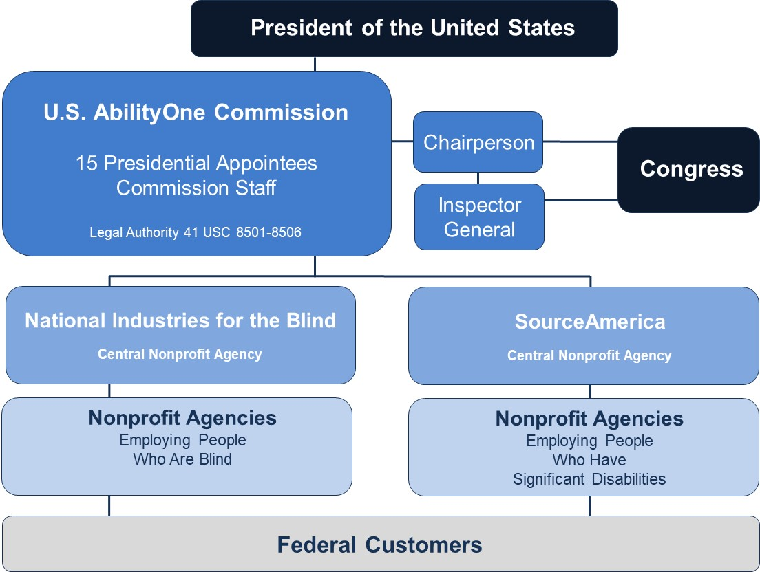

Presidential appointees on the Commission bring extensive expertise and tested judgement that promote the effective implementation of the JWOD Act, the operational efficiency of the Commission and AbilityOne Program, and the interests of people who are blind or have significant disabilities. Each appointee representing a Government agency is a senior procurement official with decades of experience in acquisition and procurement. Each private-citizen appointee is an individual with broad knowledge of the employment problems facing people who are blind or have significant disabilities.
In the past year, three departures due to retirements and the change of administrations have left the Commission with three Government agency members (Commerce, the General Services Administration and Labor) and eight vacancies (Agriculture, Air Force, Army, Defense (Defense Logistics Agency), Education, Justice, Navy and Veterans Affairs). Two private citizen positions are also vacant.
The Commission will work with the White House Presidential Personnel Office to advance nomination packages for new members. In the meantime, nearly all of the Government agencies with vacancies are represented at Commission meetings by senior acquisition officials who provide input on issues related to their respective agencies and are available for consultation on an ongoing basis.
The Commission staff of 25 Government FTEs and 8 contractors maintains Commission operations and prepares materials required by law, regulation and policy to inform the decisions made by the Presidential appointees. The Commission also has an Office of Inspector General (OIG) with 6 FTEs.
The Commission currently has designated two Central Nonprofit Agencies (CNAs) – National Industries for the Blind (NIB) and SourceAmerica – that facilitate the distribution of orders and assist NPAs participating in the AbilityOne Program.

Presidential Appointees
The following Presidential appointees served as Commission members in FY 2020 and early FY 2021:

* Indicates members who left the Commission

Jeffrey A. Koses (SES)
Chairperson
Senior Procurement Executive
General Services Administration
(Elected Interim Chairperson, October 2020; elected Chairperson, February 2021)

Robert T. Kelly, Jr.
Vice Chairperson
Private Citizen
Representing Nonprofit Agency Employees with Significant Disabilities
(Vice Chairperson or Interim Vice Chairperson since July 2018)

Thomas D. Robinson (SES)*
Chairperson (through October 6, 2020; retired)
Director of Contracting, Air Force Life Cycle Management Center,
Wright-Patterson AFB, OH
Department of the Air Force

James M. Kesteloot
Past Chairperson (July 2015 through July 2018)
Private Citizen
Representing Nonprofit Agency Employees Who Are Blind

Stuart Hazlett (SES)* (through May 2020; retired)
Deputy Assistant Secretary of the Army (Procurement)
Department of the Army

Mark Allan Schultz (SES)* (May 2020 – January 2021)
Commissioner, Rehabilitation Services Administration
Department of Education

Jennifer Sheehy (SES)
Deputy Assistant Secretary, Office of Disability Employment Policy
Department of Labor

Virna L. Winters (SES)
Director for Acquisition Policy and Oversight, Office of Acquisition Management
Department of Commerce

COVID-19 Response: The AbilityOne Essential Workforce
AbilityOne is a pivotal part of America’s response to the COVID-19 crisis. The Program’s contributions have continued at an unflagging pace throughout this extraordinary year.
AbilityOne’s most urgent priority during the COVID-19 pandemic has been to respond to the unprecedented needs of its Federal customers while protecting the health and safety of both employees and customers. The Program’s responsiveness to requirements has helped ensure the continuity of essential operations among Federal agencies, both military and civilian.
Federal customers depend on AbilityOne’s proven and reliable employees – more than 42,000 people who are blind or have significant disabilities – working at the grassroots level to meet the fast-changing demands of this national emergency. AbilityOne is instrumental in manufacturing, sourcing, and supplying personal protective equipment (PPE) to maintain the health and welfare of defense and civilian agency workforces.
Many AbilityOne employees are designated as essential and serve alongside their Federal civilian and military colleagues on the front lines of the COVID-19 crisis.

Congressional Resolutions
In the 116th Congress, the House and Senate each introduced a resolution in 2020 recognizing the vital work of people with disabilities during the pandemic and beyond.
Senate Resolution 679 observed that “essential employees with disabilities or who are blind –
(1) have continued to perform their regular duties and more throughout the COVID–19 pandemic;
(2) are vital to the economy of the United States and the territories of the United States; and
(3) were essential before the COVID–19 pandemic and will continue to be essential after the COVID–pandemic has passed into history….”
House Resolution 1266 (reintroduced in the 117th Congress as House Resolution 159) noted that during the pandemic “… people with disabilities have continued to perform this essential work even though it sometimes increased their risk of exposure to the deadly COVID–19 virus….” It also stated that the pandemic “…disproportionately impacted people with disabilities, particularly people of color with disabilities” and that “people with disabilities often work in the types of businesses identified as essential ….”

Key COVID-19 Response Actions
The Commission, NIB and SourceAmerica were in daily contact with customers throughout the Federal Government – including the Army, Air Force, Defense Logistics Agency, General Services Administration (GSA), Health and Human Services and FEMA – to identify demand for products and services during the opening months of the pandemic. In addition, the Commission regularly updated key stakeholders including the Office of Management and Budget, the Office of Federal Procurement Policy (OFPP) and Congress.
To provide AbilityOne COVID-19 information, the Commission also created a web page covering Commission actions and Program activities. The web page includes COVID-19-related guidance documents and policy changes issued by the Commission and other government agencies including the Office of Management and Budget, OFPP, DoD and GSA. This guidance was also disseminated by the CNAs to the NPAs.
One of the most important policy changes expanded exceptions to Commission policy regarding direct labor ratio requirements. Due to COVID-19 needs, many Federal agencies have stopped certain activities, and/or increased demand for products or activities that directly impact NPA contract performance and direct labor hour ratios. For example, an NPA that quickly increased production to meet unexpected demand for products as a result of COVID-19 may be forced to quickly hire people without disabilities to ensure the NPA can meet the new demand.
At the beginning of the pandemic, AbilityOne took immediate action to protect its people while surging nationwide to meet exponential increases in demand, and supporting the national emergency response at all levels of government. Uninterrupted employment has continued for the vast majority of more than 42,000 AbilityOne employees.

Commission COVID-19 Crisis Response
Rapid, transparent and frequent communication with stakeholders helps Federal agencies meet emergency needs. Throughout the crisis, the Commission has issued key guidance documents related to policies and process, including:
- Letter from Commission Chairperson to Board Chairs of NIB and SourceAmerica highlighting AbilityOne requirements and priorities
- Memo: Procurement List Change -- Scope Expanded for Make-To-Order Kits, and Manufacturing and Development Assistance -- Available to All Contracting Activities During National Emergency
- Memos: AbilityOne Flexibilities Related to the Coronavirus (COVID-19) Emergency and Recovery for the Duration of Fiscal Year (FY 2020, extended for FY 2021)
- Memo: AbilityOne Contingency Support Operations and Communications (CSOC) Team and COVID-19 National Emergency Guidance

The Commission created a Contingency Support Operations and Communications (CSOC) Team, a Commission–NIB–SourceAmerica crisis response center for AbilityOne’s COVID-19 response actions. Examples of the operational response:
- AbilityOne has continued to staff critical, uninterruptable services including dining facilities and switchboard operations at military bases and VA medical facilities.
- AbilityOne employees clean and sanitize Federal buildings, including the Pentagon and military hospitals.
- NPAs manufacture urgently needed Personal Protective Equipment (PPE) and sanitizing items, answering demand spiking as high as 1,000% above pre-pandemic levels.
- NPAs re-tooled production lines, bought equipment, hired employees, added shifts.
- Austin Lighthouse for the Blind tripled the number of employees working on hand sanitizer and soap products, and increased production from 1.2 million bottles of hand sanitizer annually to 13 million bottles between March 2020 and January 2021.
- Across 40 NIB NPAs, 3,780 people who are blind have produced 1,580 different COVID-related products as part of the response. Examples:
  - Industries of the Blind, of Greensboro, N.C., is working in a joint effort with ReadyOne Industries, a SourceAmerica NPA located in El Paso, Texas, to manufacture 838,000 camouflage face masks for the Army.
  - Several NIB NPAs partnered to produce nearly 600,000 cloth face masks for the Air Force.
- AbilityOne’s toll-free customer service number increased hours to 24/7 to provide a real-time response to Federal customers needing PPE or other products.
- Supporting the USNS Comfort deployment to New York City for its overwhelmed healthcare system, employees from VersAbility, Inc., of Hampton, Virginia, loaded meals for the crew of 1,000 before the ship sailed.
- Association for the Blind and Visually Impaired/Goodwill of the Finger Lakes, in Rochester, New York, has fielded up to 500 calls per day for a regional crisis hotline that connects community members to vital resources including food, clothing, shelter, and emergency mental health services.
- Designated as part of the country’s essential critical infrastructure, agencies worked to design safe, socially distanced workspaces and instill health protocols so employees who are blind could continue to safely produce PPE and cleaning supplies, and provide critical services for unemployment support.

NIB COVID-19 Response Highlights
- Gloves: 1.5 billion
- Disinfectants: 1.6 million gallons
- GoJo soaps: 500,000 bottles
- Purell SKILCRAFT hand sanitizer: 13 million bottles
- Masks: Nearly 2 million manufactured for Army, Air Force and DLA, in total
- Made to Order Kits: 2,660 kits supporting numerous customers. Kits consist of millions of components including wipes, masks, hand-sanitizer, gloves and alcohol pads

Protecting AbilityOne Employees During COVID-19
Protecting AbilityOne employees and, by extension, our Federal customers, is a continuing focus of the Commission, CNAs and NPAs throughout the country.

Commission
At the outset of the national emergency, the Chairperson sent a March 23, 2020, letter to the Board Chairs of NIB and SourceAmerica that began:
“As America confronts the unprecedented challenge of the novel coronavirus (COVID-19), I want to assure you that one thing will not change – the U.S. AbilityOne Commission’s commitment both to the AbilityOne mission, and to the health and safety of AbilityOne employees. For those reasons, we ask that you urge all employees to stay vigilant and informed to maintain their wellbeing and that of their loved ones and colleagues.
The most important asset of the AbilityOne Program is our people. They are a national resource that the country, at this time of great need, is calling upon to help respond to this crisis.”
In the opening months of the crisis, the Commission was in daily contact with the Executive branch, Federal customers, CNAs and NPAs to ensure shared awareness of priorities, requirements, deliverables, actions and outcomes. During those contacts, the Commission repeatedly emphasized the importance of protecting the health and safety of employees and Federal customers. The Commission continues to monitor this area.

NIB
NIB issued best practices and lessons learned to NPAs to control the spread of COVID-19 in the workplace. NIB updated its workplace and employee safety document “NPA Best Practices to Control the Spread of COVID-19 at the Workplace” to include new OSHA and other related guidance to maximize employee safety on the manufacturing floor, in office areas, and while using public transportation.
NIB maintained frequent communication between NIB staff and employees by delivering daily coronavirus messages to NIB staff and NPA CEOs, weekly CEO calls, and frequent NIB “all hands” meetings to disseminate information, answer questions, and gather first-hand reports. NIB departments conducted regular COVID-related webinars for NPA staff on several topics that included Federal relief funding, crisis communications, remote work best practices, creating safe workplaces, and dealing with common pandemic-related personnel issues.
NIB also launched NIB Connection, a corporate blog, to serve as a resource for employees, customers, and other stakeholders. Blog content includes assistive technology tips to help with telework, plus other strategies to help people who are blind cope with coronavirus-related challenges.

SourceAmerica
SourceAmerica support for NPAs included purchasing difficult-to-obtain PPE in bulk for its network. SourceAmerica enabled NPAs to equip AbilityOne employees so that they could fulfill their role in maintaining continuity of government by ensuring that Federal Government locations remain open and accessible to essential personnel.
Knowledge and resources were provided by CNA subject matter experts and a custodial trade association regarding products, equipment, processes, procedures and PPE. These enabled many AbilityOne employees to perform their essential roles while taking all available safety precautions.
SourceAmerica sent care packages of PPE to the AbilityOne NPA community in April 2020, after which it launched an online PPE Resource Order Center. The intent was to enable NPAs with a direct need to perform work on Federal Government contract sites to buy PPE at cost, and ensure the ability of people with disabilities to safely perform their job duties. These resources are available to AbilityOne NPAs and other nonprofits that employ people with disabilities.

SourceAmerica COVID-19 PPE Highlights
As of February 2021, 161 SourceAmerica NPAs placed nearly $1 million of sales orders through the online PPE Resource Order Center, including:
- 563,900 pairs of disposable nitrile gloves
- 482,800 disposable surgical face masks
- 115,100 KN95 masks
- 1,078 face shields
- 1,344 3.8 oz. sanitizer
- 680 8.45 oz sanitizer
- 116 16.9 oz sanitizer
SourceAmerica donated $255,000 of PPE to its NPAs, including:
- 63,300 disposable surgical face masks
- 63,200 KN95 masks
- 63,200 pairs of disposable nitrile gloves

Effective Stewardship

Financial and Risk Management Initiatives
The Commission’s first Chief Financial Officer (CFO) arrived in November 2020, and reports to the Executive Director. The CFO’s areas of responsibility include budget formulation, financial management, internal controls, and Enterprise Risk Management (ERM). Hiring a CFO is the latest step in a process of increasing the Commission’s focus on effective stewardship.
The CFO has taken numerous steps to enhance financial management and close out findings from financial audits and OIG reports. These actions include:
- Increased financial analysis for decision support on resource priorities
- Automated financial workflows for funds management, obligations and payments, and included increased controls
- Developed a Financial Corrective Action Plan for both FY 2019 and FY 2020 Financial Statement audit recommendations
- Drafted a Commission ERM policy
The CFO is also working with the new Commission members’ ERM Subcommittee to complete policy and procedures for implementation of the agency ERM policy.

Compliance Policies Update: Improving Oversight and Transparency
In FY 2020, the Oversight and Compliance Directorate began the Commission’s most extensive update of Compliance policies and procedures in a decade. The Commission rescinded its informal Compliance Manual and replaced it with eight modified or new policies addressing specific regulatory requirements related to AbilityOne-participating NPA qualifications, ongoing compliance, regulatory reviews and performance. These policies include detailed requirements and cover the potential consequences of non-compliance.
The Commission’s oversight and compliance responsibilities include maintaining AbilityOne integrity by monitoring CNA compliance with Commission regulations and procedures. The Commission also performs comprehensive reviews of NPA Annual Representations and Certifications, in which NPAs certify compliance with Program requirements including employment of people who are blind or have significant disabilities, labor standards, and the 75% direct labor hour ratio.
Compliance visits throughout AbilityOne shifted in March 2020, from traditional on-site visits to a virtual mode, due to travel limitations resulting from COVID-19. The Commission participated in three joint Commission-CNA compliance-related virtual visits in FY 2020.
In FY 2021, Commission Oversight and Compliance Directorate staff began to shadow CNA teams conducting compliance-related virtual visits to NPAs. The purpose of shadowing the CNA teams is to evaluate the utility of virtual visits, observe and assess the technology and processes used to review NPA records virtually, and monitor CNA performance during these visits. In FY 2021, the Commission has so far participated in one joint Commission-CNA on-site visit.
In FY 2020, NIB conducted Technical Assistance Visits – visits to assess compliance-related areas within its NPAs – to approximately 80% of its 57 NPAs with AbilityOne contracts; two-thirds of the visits were virtual. In FY 2021, NIB plans to visit each affiliated NPA at least once, either virtually or on site.
In FY 2020, SourceAmerica adapted its Regulatory Review and Assistance Visits – the equivalent to NIB’s Technical Assistance Visits – to accommodate the shift from on site to virtual. As part of the shift, CNA staff and NPAs were trained on file sharing and other IT processes required for virtual reviews. SourceAmerica plans to conduct 281 reviews in FY 2021, and has completed 96 reviews as of February 15, 2021.

Cooperative Agreements: A Framework for Accountability
The Commission continues to successfully administer the Cooperative Agreements originally signed in June 2016 with NIB and SourceAmerica – a major milestone in the agency’s oversight of the AbilityOne Program.
Previously, Commission oversight of the CNAs had been achieved primarily through regulations and policies, but without an overall framework governing the relationship between the Commission and the CNAs. By contrast, the Cooperative Agreements define the governing relationship between the Commission and its designated CNAs, and spell out the roles and responsibilities of each party. The agreements also specify the key expectations underpinning the arrangement; establish consequences for failure to meet these expectations; define metrics and a formalized process for the Commission to use in evaluating CNA activities; and provide a mechanism for feedback that enables the CNAs to improve their performance.
The authority provided by Congress to the Commission through legislation was the change agent that enabled the establishment of the Cooperative Agreements as well as an OIG. Both were longstanding Commission objectives. Congress required the implementation of written agreements in the Consolidated Appropriations Act 2016, Public Law 114-113, which directed the Commission to enter into written agreements with the CNAs to provide auditing, oversight, and reporting requirements. The U.S. Government Accountability Office (GAO) had also recommended that step in a 2013 report, which the Commission had begun working toward.
The Cooperative Agreements have proven to be invaluable tools that enable the Commission to fulfill its statutory responsibilities of overseeing the CNAs and their roles in the AbilityOne Program. This includes incentivizing them to operate efficiently, effectively and with integrity, and promoting employment for people who are blind or have significant disabilities.
Since the initial signings, the Cooperative Agreements have been renegotiated to refine and streamline them. The renegotiated agreements were signed in December 2018 (NIB) and June 2019 (SourceAmerica).
In the Consolidated Appropriations Act 2016, Congress also mandated the establishment of an Office of Inspector General (OIG) for the Commission. Discussion of the OIG’s achievements can be found within this report.

Western U.S. Field Office: Projecting Commission Oversight
Answering the intent of Congress that the Commission should assert greater oversight over the AbilityOne Program, the Western U.S. Field Office was established in 2017 with a mission to strengthen oversight, support Federal customers, and respond swiftly and efficiently to concerns. The office increases the Commission’s ability to project its presence across the entire country.
Located at Joint Base Lewis-McChord, in the state of Washington, the office oversees 111 nonprofit agencies located in 14 states – Alaska, Arizona, California, Hawaii, Idaho, Montana, Nebraska, Nevada, North Dakota, Oregon, South Dakota, Utah, Washington and Wyoming – and the territory of Guam.
In FY 2020, the office continued to promptly address the priorities and concerns of Federal customers, CNAs and NPAs, holding in-person meetings when appropriate. For example, the office conducted more than 30 meetings with Federal agencies related to current or potential AbilityOne Program orders. These meetings included facilitating discussions between a Federal customer and an NPA to preserve a contract employing 38 people with disabilities while achieving the most affordable solution for the Government.

Continuous Improvement through Quality Work Environment Initiatives
AbilityOne’s Quality Work Environment (QWE) program is a framework for continuous improvement, used to improve the experience and satisfaction of all employees at AbilityOne NPAs, with an emphasis on people who are blind or have significant disabilities. The program, which is voluntary for NPA participation, provides resources including training opportunities, productivity engineering, assessment and planning services, tracking tools and opportunities to consult with subject matter experts. The Commission component of the QWE program is led by the Deputy Executive Director.
Central to QWE is the sharing of employer best practices, with emphasis on practices that increase wages, provide training, facilitate upward mobility, provide navigation to other supports and services, and increase inclusion and integration in the workplace. A searchable database includes actions by SourceAmerica NPAs, such as:
- Hosting a charter high school in the NPA headquarters, with certified teachers and curriculum, to offer working adults an opportunity to complete their high school diploma.
- Providing a series of online financial literacy training courses with partners such as a national credit union and a regional bank.
- Creating a partnership with community employers to hold a press conference and job fair promoting the abilities of people who are blind or have significant disabilities. Over 20 local businesses participated; over 500 people attended; and more than 100 people were hired as a result of the first event.
- Providing a state-approved driver training program to assist employees in obtaining their driver’s licenses.
- Participating as a mentor with a State Committee for Employer Support of Guard and Reserve (ESR); assisting returning soldiers in resume writing, incorporating military experience, interviewing skills, and providing direct job referrals.
- Contributing 3% of each employee’s salary to a 403(b) savings account and matching 50% of the employee’s contribution up to 4%.
- Providing an online employee self-service payroll portal to allow easier access to payroll information and greater pay process efficiencies.
- Providing a variety of adaptive devices and technology as well as standard manufacturing equipment, either modified or unmodified, to allow people with significant disabilities to expand their participation in work projects, increase wages, and move through the facility independently.
- Establishing an employee self-advocacy group that focuses on communication with the larger community and assists workers in contacting and communicating with local and national legislators
Examples of QWE best practices by NIB NPAs include:
- Enrolling employees in a Quest Program to develop a training center to help them learn and develop professional skills for new career paths and potential job advancement.
- Partnering with The Hadley School for the Blind to develop a training center for employees to obtain upward mobility and professional growth by learning new professional skills.
- Creating a process to ensure that new product manufacturing contracts focus on supporting employment opportunities and roles appropriate for people who are blind.
- Partnering with Michigan Foundation for the Blind and Visually Impaired to provide free computer training to employees who are blind.
- Monitoring and updating all adaptive and accessible software to ensure continued compatibility with other standard software programs.
- Installing large touch screens on equipment with enlarged icons and operating instructions for machine operators.
- Purchasing specialized adaptive technology glasses for visually impaired employees working in manufacturing units to help enhance vision capabilities and performance.
- Initiating a benefits survey to collect employee input on what benefit elements are most important to employees and create a benefit plan that reflects those values.
- Distributing profit-sharing bonuses to manufacturing employees.
More than 80% of all AbilityOne employees work for NPAs that participate in the QWE program.

Section 898 “Panel on Department of Defense and AbilityOne Contracting Oversight, Accountability and Integrity”: Update
The Commission continues to actively participate in the 898 Panel, created when the FY 2017 National Defense Authorization Act directed the Secretary of Defense to establish the Section 898 “Panel on Department of Defense and AbilityOne Contracting Oversight, Accountability and Integrity.” The overall mission of the Panel is to address the effectiveness and internal controls of the AbilityOne Program related to DoD contracts. As required by Section 898, the Defense Acquisition University provides administrative support to the Panel, and is developing improved training related to the AbilityOne Program. While this is a DoD panel, its membership includes representatives from multiple Federal agencies.
The 898 Panel’s duties include reporting to Congress on ways to eliminate waste, fraud and abuse, and recommending changes to business practices and IT systems. The Panel currently tracks 24 recommendations, which were consolidated based on repeating themes and ideas from more than 40 recommendations from the first two annual reports to Congress.
Implementing Panel recommendations is a top priority for the Commission, which views the process as a path to innovations that will improve Federal customer satisfaction, enhance stewardship and grow employment. The CNAs and NPAs are contributing input and providing feedback as part of the Panel’s commitment to an inclusive and transparent process.
The Panel’s Third Annual Report to Congress, submitted in February 2021, noted that of the 24 recommendations being tracked, seven were completed, while the others are in various stages of implementation. The completed recommendations are:
- Implement existing policy by DoD requiring Contracting Officers to check the AbilityOne PL, and take training on the AbilityOne Program.
- CLM 023 “DAU AbilityOne Training” was updated in a collaboration between the Commission, Defense Acquisition University and the Office of the Under Secretary of Defense for Acquisition & Sustainment.
- More than 103,000 people completed the updated training between May 2018, when the updated training was deployed, and September 2020.
- U.S. AbilityOne training must be continually updated, as Panel recommendations are implemented.
- Develop policy and implement business practices that provide sufficient oversight and transparency. Create incentives for inclusion and mentoring of smaller NPAs, and for veteran employment opportunities in DoD contracts with AbilityOne NPAs.
- Reduce the existing gaps and deficiencies in CNAs’ processes.
- Update the Procurement List Information Management System (PLIMS) to reflect detailed information, improve the search functions to enable a more user-friendly interface, and be usable to outside agencies.
- Implement DoD-wide policy to designate an AbilityOne Representative (ABOR) program similar to the Air Force model and include a goal for growth in AbilityOne Program participation. (Note: For more on this recommendation, see “Increasing AbilityOne Jobs via Office of Federal Procurement Policy Actions,” below.)
- Incorporate section 508 training for contracting personnel to address DoD-wide section 508 compliance shortfall and use Defense Acquisition University online and classroom training to teach AbilityOne information.
Panel meetings in 2020 included a full session on Competitive Integrated Employment presented with the involvement of the Department of Education’s Office of Special Education and Rehabilitative Services; the Department of Labor’s Office of Disability Employment Policy (ODEP); and experts including the Director of Policy and Advocacy at the Association of People Supporting Employment First (APSE).

Commission Pilot Tests
898 Panel recommendations include pilot tests to address longstanding areas of interest within the Program. The Commission is conducting two pilot tests that have the potential to enhance value for AbilityOne Program customers, expand the Commission’s expertise, and increase Program growth and sustainability at a time of change in the economic and policy arenas.
The current Commission pilot tests are:
- NPA Competition Pilot Test – In FY 2020 the Commission completed its first-ever AbilityOne competition pilot test, in which nonprofit agencies competed for the Facility Support Operations Services contract at Fort Bliss, Texas. This pilot test achieved significant cost savings for the Army. A second competition pilot test is currently underway at Fort Meade, Maryland.
- Project Ratio Pilot Test – This pilot is exploring the potential impacts of a reduction in AbilityOne direct labor hour project ratios – specifically, by reducing the ratio from 75% to lower ratios at selected test sites. The 75% ratio refers to a statutory requirement for NPAs to employ people who are blind or have significant disabilities “for at least 75 percent of the hours of direct labor required for the production or provision of the products or services” during the fiscal year, whether or not performed on AbilityOne contracts.

Prioritizing Initiatives to Grow the Program

Increasing AbilityOne Jobs via Office of Federal Procurement Policy Actions
An unprecedented opportunity to create more AbilityOne jobs was provided through the Office of Federal Procurement Policy (OFPP) memorandum titled “Increasing the Participation of Americans with Disabilities in Federal Contracting,” issued to Chief Acquisition Officers and Senior Procurement Executives.
The memorandum directs these officials of each CFO Act agency to take five key actions to expand the reach and impact of the AbilityOne Program and other Federal resources that support employment of people with disabilities:
- Designate AbilityOne Representatives (ABORs)
- Establish Cross-Agency AbilityOne ABORs Team
- Make an AbilityOne Pledge
- Identify “Hire at Home” Opportunities within the Acquisition Workforce
- Promote Cross-Sector Partnerships and Prepare for the Future State
AbilityOne Representatives (ABORs) are contracting officers in Government agencies who act as liaisons and advocates for AbilityOne. ABORs were originally created by the Air Force in 2017, and have been proven to be highly successful as advocates for AbilityOne. They establish five-year strategic plans, review acquisition strategy documents for opportunities and work with subordinate organizations.
OFPP is encouraging agencies to reprioritize spend and make a pledge in FY 2021 equal to at least 1% of the total amount of funds obligated for contracts entered into with the agency during the fiscal year, with a further goal of increasing spend to 1.5% in FY 2022. This pledge could create tens of thousands of new jobs for individuals with disabilities – providing critical help to a chronically underserved and underemployed population.
Since the memorandum’s publication, the Commission, NIB and SourceAmerica have worked in close collaboration to determine an appropriate strategy to support the memorandum’s purpose “to create a stronger pathway for the increased participation of persons with disabilities in Federal contracting through the AbilityOne Program” and “promote greater awareness and use within the Federal acquisition workforce of other Federal programs that facilitate employment of persons with disabilities.”
The Commission and CNAs have met with OFPP to discuss marketing and education support for ABORs, including what content should be developed and where it should be disseminated. Where ABORs have been identified, initial meetings between designated CNA staff and the ABORs have taken place. The Commission and CNAs have also provided trainings and capabilities presentations for several Federal agencies.
In addition to designating an ABOR Program Manager, the Commission is providing spend breakouts to each agency and, to assist contracting officers, targeting upcoming expiring contracts that AbilityOne NPAs could perform. The Commission Chairperson and staff briefed the Chief Acquisition Officers Council (CAOC) on the OFPP memo and how their agencies could further support AbilityOne.

Accelerating Elimination of Subminimum Wages and 14(c) in AbilityOne
The Commission continues to accelerate the process of phasing-out payment of subminimum wages in AbilityOne under 14(c) certificates.
The Commission’s position is that all employees – with or without disabilities – should be paid at least the applicable minimum wage when the authority of the AbilityOne Program is used to award Federal contracts.
For that reason, the Commission’s Spring 2021 Regulatory Agenda includes a proposed rule to change the regulatory suitability criteria for AbilityOne products and services to explicitly include consideration of the payment of minimum wage, prevailing wages, or higher wages to people who are blind or have significant disabilities.
The Commission will continue to review the recommended Fair Market Prices for the products and services proposed for addition to the AbilityOne Procurement List and will ensure that the appropriate wage rates are incorporated.
This action follows a series of Commission steps toward eliminating AbilityOne Program use of the 14(c) certificates, which allow for paying subminimum wages to people with disabilities on AbilityOne contracts. Section 14(c) certificates are authorized by the Fair Labor Standards Act, enacted in the 1930s when subminimum wages were seen as a way to improve employment prospects for people with disabilities. While this Federal legislation is still in effect, times have changed, as have attitudes, policies and technologies – and the Commission has acted accordingly.
Fewer than 2% of AbilityOne employees – an estimated 674 employees out of more than 42,000 – were paid below the Federal minimum wage in the first quarter of FY 2021.
NIB reports that all of its associated NPAs pay the full applicable minimum wage or higher on all AbilityOne contracts.
SourceAmerica reports a downward trend in use of 14(c) certificates within its NPA network and on AbilityOne contracts.
Commission steps to end payment of subminimum wages on AbilityOne contracts include:
- 2016 – The Commission issued its “Declaration in Support of Minimum Wage for All People Who Are Blind or Have Significant Disabilities.”
- 2019 – The Commission called on SourceAmerica to accelerate the process of ending the payment of subminimum wages by NPAs associated with SourceAmerica on AbilityOne contracts.
SourceAmerica responded by launching its 14(c) Transition Program to provide consultation, knowledge and data sharing, technical support, and financial assistance through a flexible grant program intended to support NPA transition activities. In 2020, SourceAmerica’s board of directors passed motions including one stating that the Board does not support awarding new AbilityOne contracts that require work under 14(c).
- 2020 – The Commission initiated a new practice to identify and report in the Presidential Appointees’ decision documents any planned use of subminimum wages related to products and services that are candidates for addition to the AbilityOne Procurement List.
In addition to the actions described above, SourceAmerica began issuing 14(c) Transition Program financial assistance grants in FY 2020 to support NPA efforts at eliminating or significantly reducing the use of 14(c) certificates. To date, $400,000 of approximately $1 million in yearly grant funding has been awarded to support transition efforts by SourceAmerica NPAs with AbilityOne contracts. The following three grants are intended to span the transition process, including planning, implementation, and sharing of knowledge and expertise in transition.
- The Mentoring and Exploration grant is available to support NPAs while exploring options for and developing a transition plan. It is available to support mentoring relationships between a transitioned NPA and one beginning the transition process, or to fund site visits, consultants, and other exploration-related activities. The grant reimburses up to $15,000 in NPA costs.
- The Enterprise Innovation grant provides up to $100,000 to NPAs to support transition efforts. The grant is intentionally flexible to support the unique needs and plans of NPAs, rather than imposing a prescribed set of activities.
- NPAs that have successfully transitioned from 14(c) certificates can receive a Replication grant to provide training, toolkits, and other shareable resources to SourceAmerica’s network. The grant reimburses up to $10,000 in NPA costs.
NIB has a longstanding commitment to eliminating 14(c) certificates and creating programs that help NIB-associated agencies increase employee productivity and compensation. These include NIB’s Productivity, Training, and Compliance (PTC) grant and NIB’s Rehabilitation Engineering Program.
The PTC grant is part of an NIB financial program that features several grants, incentives and loans available to eligible associated agencies that pay at least the Federal minimum wage. Eligible associated agencies apply for a PTC grant to purchase equipment and technology to support expanding business lines and hiring more people who are blind. NIB’s Rehabilitation Engineering Program is led by specially trained rehab engineers who visit agencies to make employee workplaces and equipment more accessible to people who are blind and maximize employee productivity and effectiveness. Both initiatives are designed to support the NIB board of directors’ position on the critical importance of supporting compensation above the Federal minimum wage.

Rising Average Hourly Wages in AbilityOne
AbilityOne average hourly wages rose by more than 33% from FY 2010 to FY 2020 – from $11.00 in FY 2010 to $14.70 in FY 2020.
Employees with disabilities now earn an average wage of $15.64 per hour on AbilityOne contracts at SourceAmerica NPAs, as of Q2 FY 2021.
In FY 2020, more than $675 million in wages were paid to AbilityOne direct labor employees. Additionally, more than 75% of those employees worked on Federal contracts covered by the Service Contract Act, for which the Health and Welfare Fringe Benefit Rate established by the Department of Labor was $4.54 per hour in FY 2020. For AbilityOne employees working on service contracts, the Commission estimates that they received at least an additional $150 million in fringe benefits during FY 2020.
The vast majority of AbilityOne providers pay competitive wages with benefits and provide career tracks so that employees in the Program can be given the opportunity to experience full community integration and inclusion (e.g., homeownership, and involvement in every aspect of their respective communities).
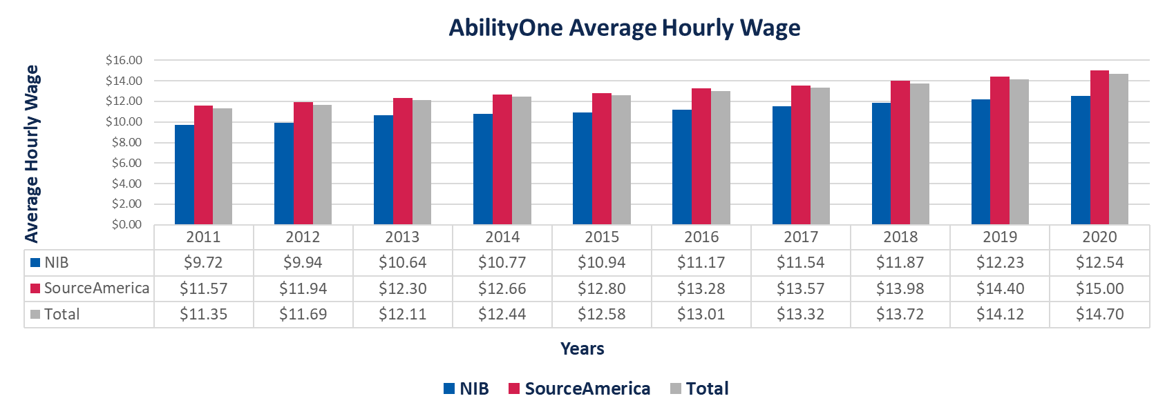

Increasing Next Generation Knowledge-Based Jobs
Recognizing that employment trends point to a new direction for AbilityOne opportunities, the Commission has prioritized adding more knowledge-based jobs to the Program. Certain AbilityOne contracts already fall into the knowledge-based area, and the CNAs have intensified their efforts to increase focus on next generation jobs in this area by launching initiatives in IT and knowledge-based areas.
The Commission’s use of the phrase “knowledge-based jobs” refers to knowledge work, a management theory phrase often used to describe work that involves certain kinds of expertise, education or experience. Examples include information technology, finance and government contracting.
To make these opportunities more attractive to Federal agencies, the Commission will be flexible with temporary Procurement List additions and other ways to allow agencies to introduce new services without making a permanent commitment.

NIB
NIB is pursuing a variety of initiatives to generate knowledge-based jobs, including:
- Launched the NIB Cisco Academy, the first Cisco Certified Network Associates training program adapted to the learning styles of people who are blind. The academy provides foundational knowledge of a broad range of IT fundamentals.
- Launched NSITE, a talent management service tailored to job seekers who are blind, visually impaired, and/or veterans. NSITE offers job placement services as well as talent development and accessibility support.
- Rolled out the virtual Business Essentials training program, which helps participants build a greater understanding of business elements, decision making and entrepreneurship.
- During COVID-19, coordinated with East Texas Lighthouse to shift NIB’s Professional Mastery of Office Technology for Employment (ProMOTE) training program to virtual training.
- Introduced the Association Management Fellowship pilot for people who are blind to obtain experience in event planning, marketing and communications, accounting and finance, and human resources as they earn a Certified Nonprofit Professional credential from the Nonprofit Leadership Alliance.
- Piloted an initiative with the Air Force Life Cycle Management Center to actively recruit and hire people who are blind and visually impaired for contracting positions. NIB hosted and facilitated a virtual career fair for the Air Force with 82 participants; NIB provided five of the eight candidates hired by the Air Force.
- Additionally, NIB recently celebrated the 10th anniversary of the Contract Management Support program, which has employed more than 200 people who are blind in upwardly mobile career contracting positions, including more than 80 who are now employed in government or the private sector.

SourceAmerica
SourceAmerica is pursuing a pilot project for User Experience (UX) testing services performed by people with disabilities for the Federal Government. This UX pilot project will be undertaken in coordination with the GSA 18F office, which is the primary agency responsible for coordinating UX services on behalf of the Government. This pilot is informed by a UX pilot SourceAmerica recently completed with a major technology company.
Examples of current SourceAmerica projects in the area of knowledge-based jobs include:
- IT Service Desk Support, U.S. Department of Agriculture, 123 DFTE – Provides service desk support to end users and Government IT support staff.
- IT Services, Defense Manpower Data Center, 80 DFTE – Provides DoD with IT services related to major programs including verifying military entitlements and benefits; managing the DoD ID card issuance program; providing identity management; helping identify fraud and waste in pay and benefit systems; personnel and property identification, authentication, and access control systems; personnel evacuation support systems; conducting personnel surveys; and assisting military members and their spouses with relocations, quality of life issues and post-service job searches.

Commission
Seeking to add more knowledge-based jobs to the Program, in 2018 the Commission designated the American Foundation for the Blind (AFB) as an AbilityOne-authorized CNA with focus areas including knowledge-based jobs for people who are blind. In 2020, AFB successfully completed the initial phase of its Cooperative Agreement with the Commission – a research and studies phase designed to identify innovative business models and practices that increase employment opportunities for blind individuals in knowledge-based careers.
While AFB ultimately opted not to pursue the next phase of its Cooperative Agreement with the Commission, its work during the first phase significantly advanced the Commission’s understanding of technology-related and other emerging career fields that present opportunities for people who are blind. The Commission will use the knowledge gained to continue to explore additional opportunities to create more jobs in the AbilityOne Program.

Competitive Integrated Employment in AbilityOne
AbilityOne continues to take steps toward a future that includes more Competitive Integrated Employment.
The AbilityOne Program’s enabling legislation, the Javits-Wagner-O’Day (JWOD) Act, was originally enacted in 1938 and last substantively updated in the 1970s.
Disability civil rights laws passed since the 1990s do not make reference to, or changes to, the JWOD Act’s requirement that 75% of a qualified NPA’s direct labor hours must come from the target population during the fiscal year.
The JWOD Act’s 75% direct labor hour ratio is viewed in some quarters as a hindrance to integration, and as lacking alignment with more recent disability-related employment laws.
Both before and during its work with the 898 Panel, the Commission has been open to a lower direct labor hour ratio of employees as a way to increase integration in the Program. As a result of an 898 Panel recommendation, the Commission is conducting a Project Ratio Pilot Test to explore the potential impacts of a reduction in AbilityOne direct labor hour project ratios on disability employment. (See “Commission Pilot Tests,” above.)
Many AbilityOne jobs are consistent with the criteria for Competitive Integrated Employment established by more recent law (see below). This position has been expressed to the Department of Education. The Air Force Personnel Center support contract at Randolph AFB, Texas, is an example: Goodwill and Air Force employees work side-by-side.
Operational practices and workplace settings for a majority of AbilityOne jobs mirror those of commercial contractors performing similar work in Federal buildings, on military installations, and in manufacturing locations. Examples of jobs that AbilityOne considers Competitive Integrated Employment can be found in Appendix 2.
The Workforce Innovation and Opportunity Act requires Vocational Rehabilitation (VR) counselors to review each job on a case-by-case basis. Each example in Appendix 2 meets the three-part definition of Competitive Integrated Employment as expressed in law:
- Individuals with disabilities interact with other persons without disabilities to the same extent that individuals without disabilities would in comparable positions.
- There are opportunities for advancement.
- Compensation levels are at or above prevailing minimum wages with equal access to benefits.
The Appendix 2 examples provide a snapshot of more than 100 AbilityOne jobs that are available through the Program. This subset of AbilityOne work reinforces the need to carry out case-by-case determinations and remove conflicting guidance that may deter individuals with disabilities from participating in jobs that meet Competitive Integrated Employment standards. The Commission is committed to developing AbilityOne opportunities for Competitive Integrated Employment where possible.

Improving Communication: Commission and Rehabilitation Services Administration
On January 19, 2021, the Commission and the Rehabilitation Services Administration (RSA) of the Department of Education executed a Memorandum of Understanding through which the agencies agree to work together to increase communication and understanding regarding which opportunities are appropriate for persons who are blind to operate vending facilities under the Randolph-Sheppard Act, and which are appropriate for placement on the AbilityOne Procurement List under the JWOD Act.
In addition, the Commission and RSA agreed to work together to expand entrepreneurial and other employment-related opportunities for individuals who are blind or have significant disabilities.

Veterans Employment and Initiatives
Serving veterans is an important aspect of the AbilityOne Program. AbilityOne NPAs provide veterans with numerous wounded warrior transition programs, training and employment opportunities. Commission and CNA staff also seek veterans’ employment opportunities by pursuing 898 Panel recommendations and assisting AbilityOne NPAs with identifying lines of business requiring the professional skills that veterans gain from military experience.
More than 3,200 wounded, ill or injured veterans currently work in AbilityOne direct labor jobs. In addition, NPAs employ nearly 4,000 veterans working in indirect labor positions, including supervisory and management roles. In total, approximately 7,000 veterans work at AbilityOne NPAs. The range of their military service stretches from Vietnam to Afghanistan and Iraq.
Many veterans have hidden disabilities. A veteran may appear uninjured but suffer from combat injuries such as a traumatic brain injury or post-traumatic stress disorder (PTSD). Like veterans with unseen disabilities, AbilityOne employees who have autism, or who are blind or deaf, are representative of those making highly visible contributions to the country during the COVID-19 crisis, but with disabilities that may be invisible.
Increasing long-term, stable employment for veterans who are blind or have significant disabilities, consistent with the JWOD Act, is the objective of the Commission’s Directorate of Veterans Employment and Initiatives. The directorate collaborates extensively with the 898 Panel to advance the work of the Panel’s Employment Initiatives and Veterans Eligibility subcommittee, and recruited a retired Sergeant Major of the Army to lead the subcommittee. The directorate led a collaboration with the nonprofit community to establish a nationwide veterans-focused apprenticeship program that was recognized by the Department of Labor in February 2020.
The Commission continues to seek opportunities to increase employment opportunities for veterans by educating and informing Government agencies, Veteran Service Organizations and Military Support Organizations.

Office of Inspector General

OIG Builds Oversight Foundation for Stronger Commission and Program
The Commission’s OIG provides quality reports, recommendations and oversight for the Commission and AbilityOne Program. In May 2017, pursuant to a statutory mandate from Congress, the Commission appointed Thomas K. Lehrich as its first Inspector General, achieving independent oversight for the first time since the Commission’s establishment in 1938, more than 80 years ago. In 2020, OIG issued two Semi-Annual Reports to Congress, a number of high impact audit reports, and two valuable management alerts to the Commission. Despite its young age, the OIG has succeeded in enhancing confidence in the Program, improving economies and efficiencies, and promoting Program growth. OIG’s work preserves jobs for Americans who are blind or have significant disabilities and ensures the integrity of goods and services offered to the Federal customer.
Through audits and investigations using a risk-based model, as well as through partnerships with other agencies, OIG leverages limited resources to maximize impact on Program risk areas. As a roadmap to its strategic vision, OIG released a Biennial Audit Plan for FY 20-21. The Plan includes five statutorily mandated audits of the Commission and nine discretionary audits of the Program. The implementation of Cooperative Agreements, DoD 898 Panel recommendations, and emerging challenges are among many of the priorities that impact the Program’s capability to provide job opportunities for people who are blind or have significant disabilities.
OIG’s Office of Investigations produced two significant civil fraud settlements and is currently investigating several hundred million in potential contract fraud. On September 30, 2020, DOJ announced the NPA, Industries for the Blind and Visually Impaired Inc., of Wisconsin, agreed to settle for $1.9 million allegations of false claims and kickbacks. In its official press release, DOJ quoted the IG: “We are committed to preserving the integrity of the AbilityOne program. False claims on the program exclude blind and significantly disabled workers from opportunities and hinders law-abiding AbilityOne contractors- Working with DOJ and our partners, the Office of Inspector General protects the confidence and public trust in the largest employment program in the nation of blind and significantly disabled workers.”
To leverage limited resources, OIG established a Knowledge-Based Center with the goal of providing additional OIG staffing and support through internships, rotations, details, CIGIE Fellows, Wounded Warrior Fellows, and other shared services and MOUs with government agencies.
As a part of a continuous effort to deepen its understanding of the Program that it oversees, OIG conducts NPA knowledge visits, presents at conferences, routinely meets with and briefs the Commission, and speaks with industry experts. This outreach is designed to inform the AbilityOne Program community of the function of the newly established OIG, and to promulgate the IG’s message of promoting integrity and efficiency, while also preventing waste, fraud, and abuse. During COVID-19, OIG provided fraud awareness trainings, including CARES Act briefings to the Commission and the CNAs.
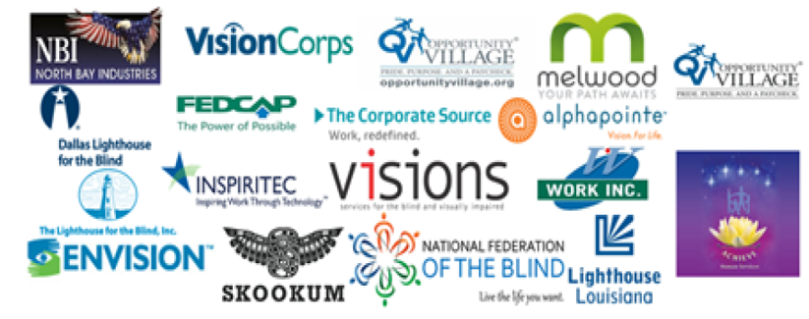
As an active member of the Council of the Inspectors General on Integrity and Efficiency (CIGIE), OIG continues to lead and participate in CIGIE programming. In 2020 OIG helped develop a web page for IGs across the Federal government as part of a CIGIE working group to enhance and further build the capabilities of oversight.gov for the IG community. AbilityOne OIG’s analysis of enterprise risk management was included in CIGIE’s Top Management and Performance Challenges Report Facing Multiple Federal Agencies.
The IG is a statutory member of the DoD 898 Panel and chairs the Inspector General Subcommittee. Additionally, OIG provides support and advice to multiple 898 Panel subcommittees dealing with the effectiveness and internal controls of the AbilityOne Program as it relates to DoD contracting, including to the DOJ-led subcommittee on Waste, Fraud, and Abuse.
OIG, in total, provided 67 concrete recommendations to improve the Program. The Commission took actions to successfully implement the recommendations in 6 out of the 67 recommendations (roughly 9%), and OIG closed these six recommendations in the first quarter of FY21. The following graph is an overview of the 61 open recommendations.
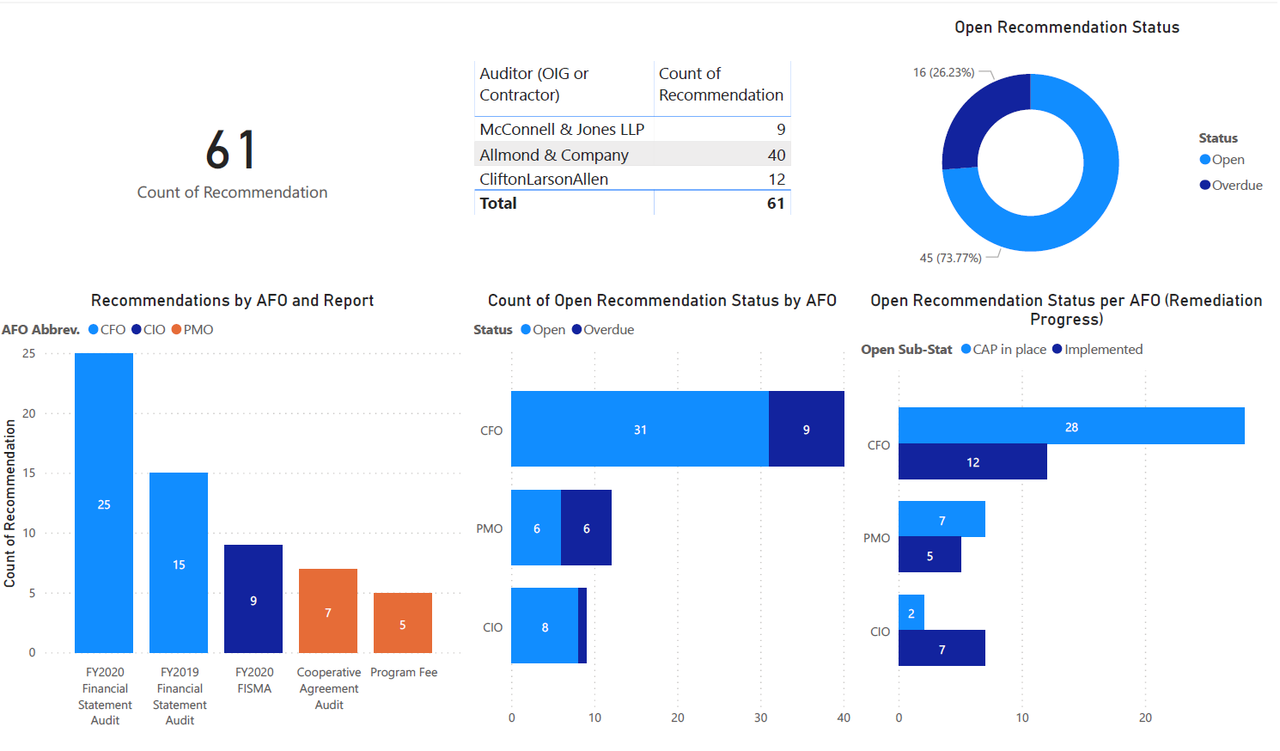
In FY21, Congress increased OIG’s appropriations to $2.5 million, which allows OIG to further build the oversight program. The work of OIG in preserving the confidence of the Program is building a better future for the Commission while helping to create opportunities for Americans who are blind or have significant disabilities.

AbilityOne Nonprofit Agencies and Sales by State

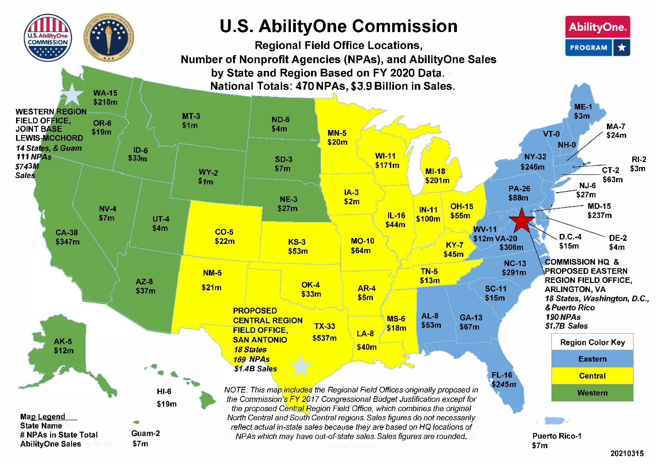

AbilityOne by the Numbers

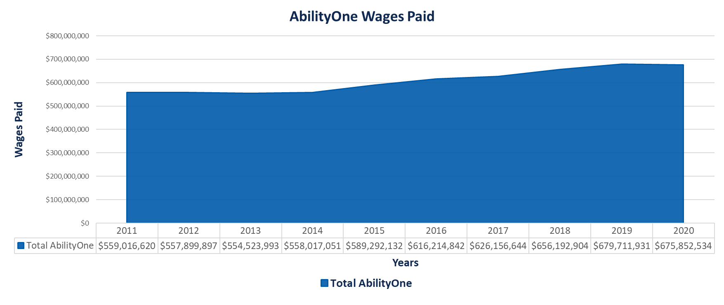

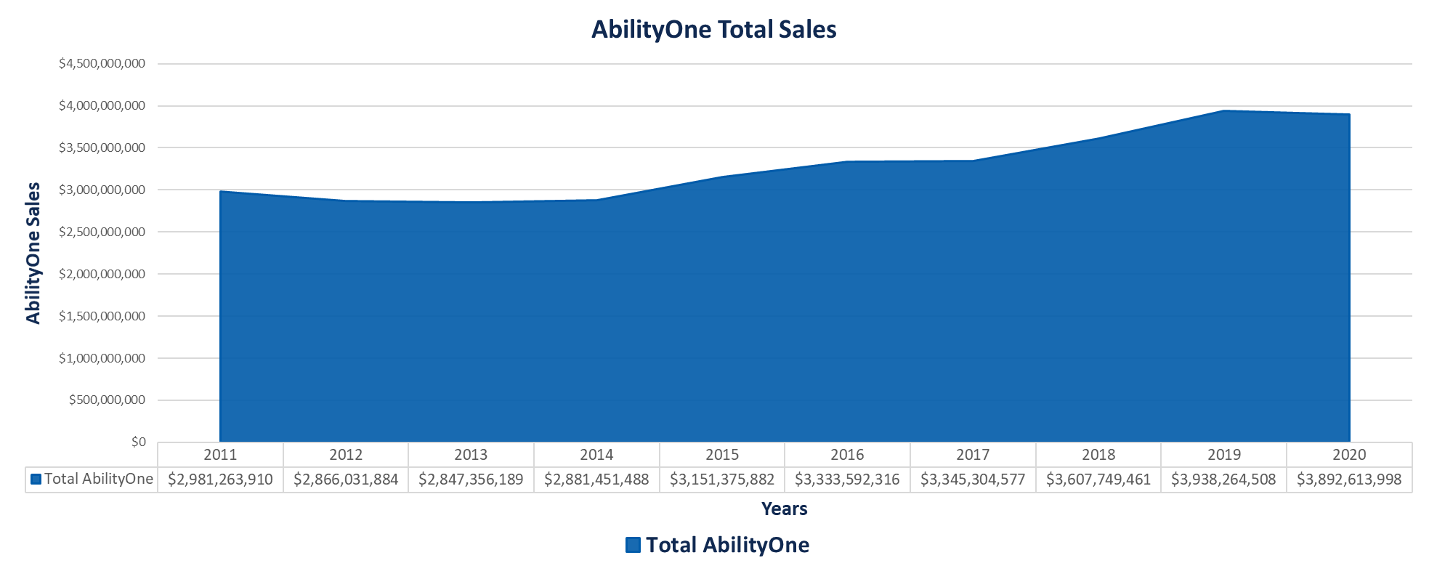

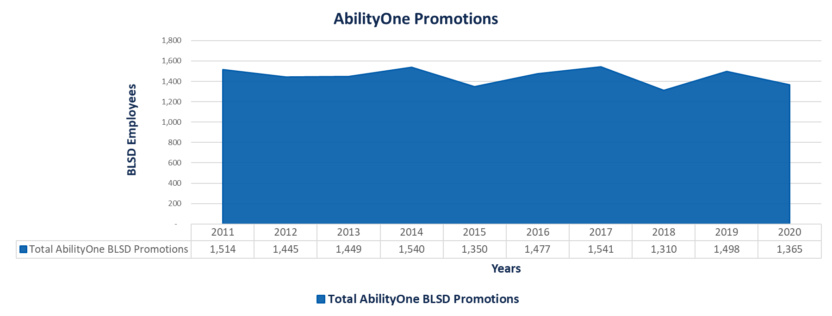

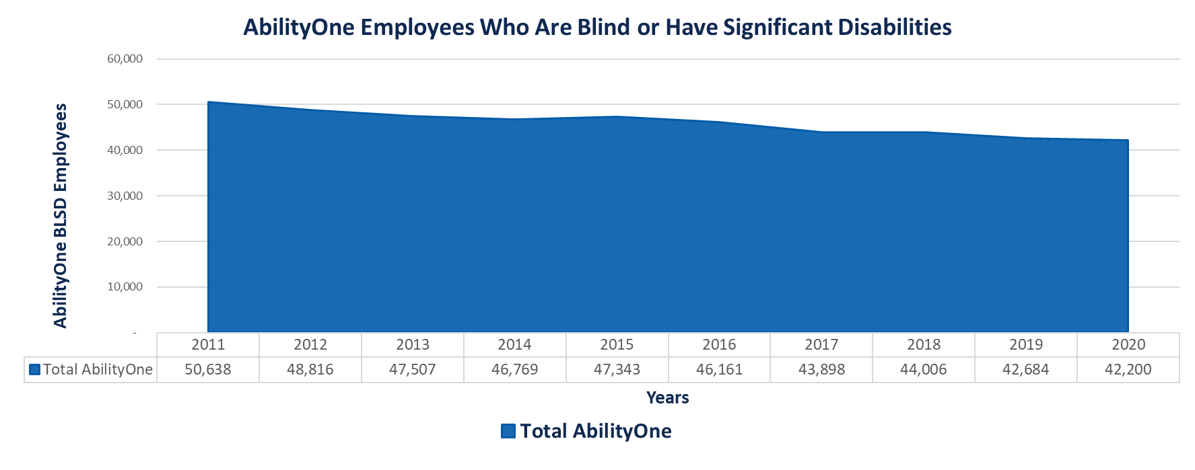

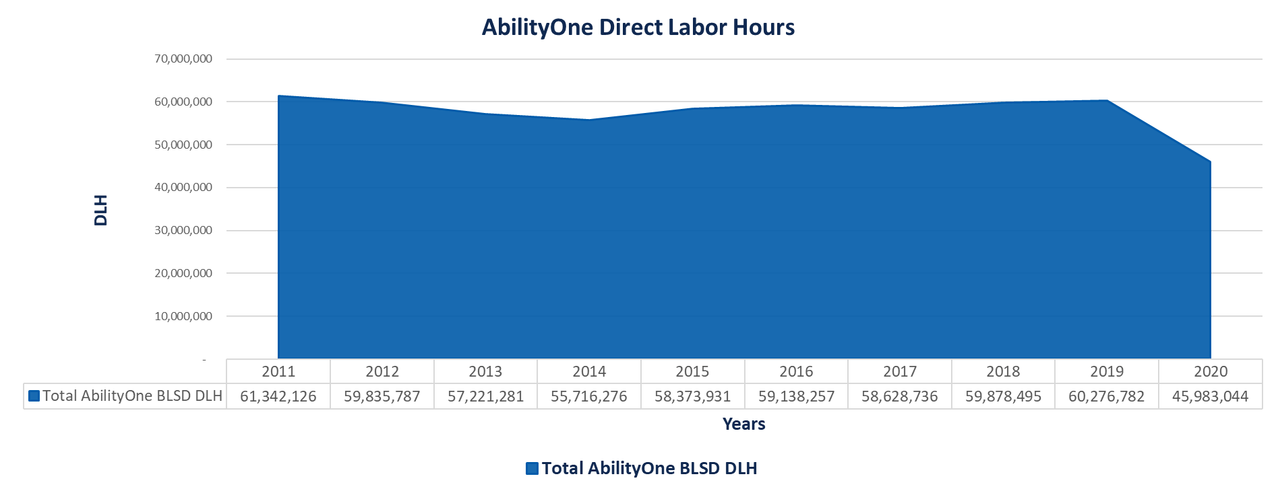

Note: On graphs above, BLSD refers to people who are blind or have significant disabilities.

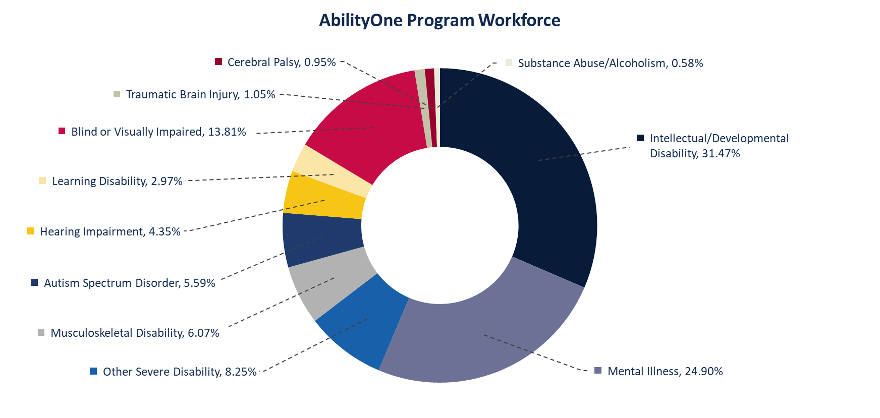

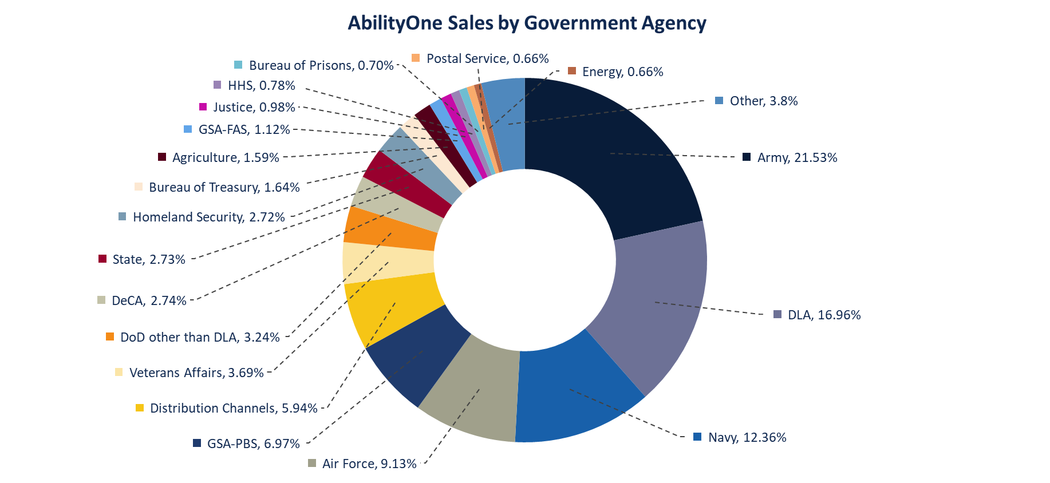

Appendix 1: Dates of Commission Meetings
Regular Commission public meetings are held on a quarterly basis; however, special meetings may be called by the Chairperson at any time.
FY 2020 Commission public meetings:
- October 16, 2019
- February 12, 2020
- April 7, 2020 (cancelled due to pandemic)
- July 17, 2020 (virtual)
FY 2021 Commission public meetings to date:
- October 6, 2020 (virtual)
- January 14, 2021 (virtual)

Appendix 2: Examples of Competitive Integrated Employment in AbilityOne
Competitive Integrated Employment Examples
Job Type | Compensation (Average Wages) | Benefits | Integrated Setting | Advancement
Custodian Operations at Senate office buildings | $15 per hour | Health & Welfare benefits (H&W) included as required by Service Contract Act | Interact with coworkers, elected officials, congressional staff, and the general public | Upward mobility including career training is offered to all AbilityOne employees
Custodian Operations at the Eisenhower Executive Office Building, White House Complex | $14.90 per hour | H&W benefits included as required by Service Contract Act | Interact with coworkers, elected officials, White House staff, and the general public | Upward mobility including career training is offered to all AbilityOne employees
Custodian Operations at the Statue of Liberty National Monument | $25.79 per hour | H&W benefits included as required by Service Contract Act | Interact with coworkers and the general public | Upward mobility including career training is offered to all AbilityOne employees
Food Services at Armed Forces Retirement Homes (DC and Florida) | $15.76 per hour | H&W benefits included as required by Service Contract Act | Interact with coworkers, retired veterans | Upward mobility including career training is offered to all AbilityOne employees
Shipboard Provisioning for the Navy at multiple installations | $11.37 to $27.97 per hour | H&W benefits included as required by Service Contract Act | Interact with coworkers and work along with Navy Personnel to load and unload provisions from the ship | Upward mobility including career training is offered to all AbilityOne employees
Total Facilities Management for the Army Reserve and National Guard | $17.31 to $37.22 per hour | H&W benefits included as required by Service Contract Act | Interact with coworkers and work side by side with Dept of Defense personnel as well as private contractors | Upward mobility including career training is offered to all AbilityOne employees
Technical Support Service for the Program Executive Office of the Army | $21.50 to $34.57 per hour | H&W benefits included as required by Service Contract Act | Interact with coworkers and military personnel | Upward mobility including career training is offered to all AbilityOne employees. Many employees working on this contract become a Federal employee.
Contact Center Services and IT Service Desk for Fort Knox | $13.37 per hour | H&W benefits included as required by Service Contract Act | Interact with coworkers and all levels of military personnel world-wide | Upward mobility including career training is offered to all AbilityOne employees
Food Service, Sheppard Air Force Base | $11.50 to $18.06 per hour | H&W benefits included as required by Service Contract Act | Interact with coworkers and military personnel | Upward mobility including career training is offered to all AbilityOne employees
Mailroom Operations at multiple Federal buildings throughout the country | $16.57 per hour | H&W benefits included as required by Service Contract Act | Interact with coworkers, Federal government personnel, and the general public | Upward mobility including career training is offered to all AbilityOne employees
Total Facilities Management at the WHS Mark Center | $15.24 per hour | H&W benefits included as required by Service Contract Act | Interact with coworkers, DoD personnel, and commercial private contractor employees | Upward mobility including career training is offered to all AbilityOne employees
Food Production for USDA | $14.50 per hour | Health benefits including vacation hours are offered | Interact and work alongside production operators like any other private-owned manufacturers | Upward mobility including career training is offered to all AbilityOne employees
Mail Tray Assembly for the USPS | $13.25 per hour | Health benefits including vacation hours are offered. Bonus plan also offered | Interact with other production operators like any other private-owned manufacturers | Upward mobility including career training is offered to all AbilityOne employees
Medical First Aid Kits for Department of Defense | $9.49 per hour | Health benefits including vacation hours are offered | Interact with other production operators like any other private-owned manufacturers | Upward mobility including career training and outplacement is offered to all AbilityOne employees
Combat Identification Kits for US Army | $8.97 per hour | Health benefits including vacation hours and retirement plan are offered | Interact with other production operators like any other private-owned manufacturers | Upward mobility including career training is offered to all AbilityOne employees
BSC Cashier | $12.50 per hour | Medical, retirement, profit-sharing, and holiday bonus | Interact with coworkers, base customers | Initial job assessment and training, upward mobility opportunities including management positions
Switchboard Operator | $13.71 per hour | Health & Welfare (H&W) benefits included as required by Service Contract Act | Interact with coworkers, inbound callers | Career training and upward mobility offered to all employees; internal candidates sought for openings before seeking outside candidates

Appendix 3: Report Terminology
898 Panel: The “Panel on Department of Defense and AbilityOne Contracting Oversight, Accountability and Integrity,” established in accordance with Section 898 of the FY 2017 National Defense Authorization Act.
ABOR: AbilityOne Representative. A designated individual who “advocates federal buying in accordance with mandatory source contracting procedures, engages with the workforce to build use of the Program, and offers feedback to the U.S. AbilityOne Commission to improve the value of the Program.” (see Office of Federal Procurement Policy memo “Increasing the Participation of Americans with Disabilities in Federal Contracting.”)
AFB: American Foundation for the Blind. Designated as a CNA in 2018, AFB successfully completed the initial phase of its Cooperative Agreement with the Commission and decided not to pursue the second phase, thereby ending AFB’s status as a CNA effective December 31, 2020.
AFO: Audit Follow-Up Official, the person or office responsible for ensuring that recommendations are implemented.
CNA: Central Nonprofit Agency. The Javits-Wagner-O’Day Act directs the Commission to designate “a central nonprofit agency or agencies (CNA or CNAs) to facilitate the distribution” of government orders of Procurement List products and services among nonprofit agencies employing people who are blind or have significant disabilities. The Commission has designated National Industries for the Blind (NIB) and SourceAmerica as the national nonprofit organizations that perform this function and otherwise assist nonprofit agencies with participation in the AbilityOne Program.
Committee for Purchase From People Who Are Blind or Severely Disabled: Statutory name for the U.S. AbilityOne Commission, which is the operating name for the agency.
CSOC: “COVID-19 Contingency Support Operations & Communications” team, the single point of contact for AbilityOne Program COVID-19 activities, established in March 2020.
Direct labor: Per 41 U.S.C. 8501: “The term ‘direct labor’—(A) includes all work required for preparation, processing, and packing of a product, or work directly relating to the performance of a service; but (B) does not include supervision, administration, inspection, or shipping.”
Direct Labor Hour Ratio: AbilityOne NPAs must employ people who are blind or have significant disabilities for at least 75% of their overall direct labor hours during the Federal fiscal year, in accordance with the JWOD Act and Commission regulations.
Javits-Wagner-O’Day Act: Enabling statute for the Committee for Purchase From People Who Are Blind or Severely Disabled, now operating as the U.S. AbilityOne Commission. The statute is also known as the JWOD Act (41 U.S.C. §§ 8501-8506).
NIB: National Industries for the Blind, one of the Commission’s two designated Central Nonprofit Agencies.
NPA: A nonprofit agency serving people who are blind or who have significant disabilities.
PL: See Procurement List
Procurement List: A list of commodities (including military resale commodities) and services the Commission has determined suitable to be furnished to the Government by nonprofit agencies for the blind or nonprofit agencies employing persons with significant disabilities pursuant to the JWOD Act and associated regulations.
SourceAmerica: A nonprofit serving people with a range of disabilities, one of the Commission’s two designated Central Nonprofit Agencies.
U.S. AbilityOne Commission: Operating name for the agency. The statutory name is the Committee for Purchase From People Who Are Blind or Severely Disabled.
Report terminology does not represent legal or technical definitions, which are available in Policy 51.102, “Definitions of Terms,” in the Commission Policy section of AbilityOne.gov.

To reflect the most current information available, this report covers FY 2020 through March 15, 2021.
Expressing Appreciation and Support for Essential Employees with Disabilities or Who Are Blind During the COVID–19 Pandemic, and Beyond, S.Res 679, 116th Cong. (2020). Expressing Appreciation and Support for Essential Employees with Disabilities During the Current Pandemic, and Beyond, H.R. Res. 1266, 116th Cong. (2020) and H.R. Res. 159, 117th Cong. (2021).
In FY 2020, 211 NPAs applied for exceptions to direct labor hour ratio requirements (28 NIB, 183 SourceAmerica). So far in FY 2021, 199 NPAs have applied for ratio relief (26 NIB, 173 SourceAmerica).
Commission Chairperson Thomas D. Robinson letter to Dr. Paul M. Healy, Chairperson of the Board, NIB, and Norman Lorentz, Chairman of the Board, SourceAmerica, March 23, 2020.
U.S. Government Accountability Office, “Employing People With Blindness or Severe Disabilities: Enhanced Oversight of the AbilityOne Program Needed” (Washington, D.C., 2013).
The Quest Program at the Central Association for the Blind and Visually Impaired (CABVI) located in Utica, New York, is an integrated program to help both sighted and blind employees prepare for career growth. Participants meet regularly over the course of 10 months to attend lectures, study topics, participate in discussions, and take part in group activities and projects. Graduation from the program will be included in the relevant experience considered when supervisory positions become available at CABVI.
Panel on Department of Defense and AbilityOne Contracting Oversight, Accountability and Integrity (898 Panel), First Annual Report to Congress (Washington, D.C., 2018); Second Annual Report to Congress (2020); and Third Annual Report to Congress (2021). All reports also available on the Defense Pricing and Contracting website.
Panel on Department of Defense and AbilityOne Contracting Oversight, Accountability and Integrity (898 Panel), Third Annual Report to Congress, 17.
Javits-Wagner-O’Day (JWOD) Act (41 U.S.C. §§ 8501-8506)
As of March 15, 2021, 11 out of 24 CFO Act agencies have made a pledge to increase their agency’s percentage of spend on products and services from AbilityOne.
U.S. AbilityOne Commission, “Declaration in Support of Minimum Wage for All People Who Are Blind or Have Significant Disabilities” (Arlington, Va., 2016).
U.S. AbilityOne Commission, “Commission Calls for End to Payment of Subminimum Wages on AbilityOne Contracts at SourceAmerica Nonprofit Agencies” (Arlington, Va., 2019).
NIB Cisco Academy
NSITE
A DFTE (Disabled Full Time Equivalent) represents one full-time position on an annual basis. A DFTE can represent one person or multiple persons simultaneously if they work less than full-time schedules.
Semiannual Report to Congress, October 1, 2019 - March 31, 2020; Semiannual Report to Congress, April 1, 2020 - September 30, 2020; “Management Alert,” December 6, 2020; “Management Alert,” July 24, 2020.
OIG FY 2020-2021 Audit Plan, March 31, 2020.
Department of Justice, “Wisconsin-Based Nonprofit To Pay $1.9 Million To Settle Allegations Of False Claims And Kickbacks On Federal Contracts For Blind Workers” (press release), September 30, 2020; “Memphis Goodwill Industries, Inc. will pay $150,000 to the United States for Claims that were in violation of the Federal False Claims Act,” (press release), June 19, 2019.
Council of the Inspectors General on Integrity and Efficiency, Top Management and Performance Challenges Facing Multiple Federal Agencies, February 2021.

